Introductory to Operating Systems
COP 4600-002
Name and ID __Sean Dunford___U66807525_____
Homework #3
Q1. Consider a paging system with main memory access time of 20 nanoseconds (this includes the effect of the page table hit ratio). Assume that it takes 650 microseconds to bring a page from disk to main memory when no frame replacement is needed. When page replacement is needed it takes 850 microseconds if the frame has not been modified and 1.5 milliseconds if the frame has been modified. Assume that on the average the system experience a page hit 99.995% of the time it addresses memory and that 25% of the time a page fault occurs the frame needs to be replaced. When a frame needs to be replaced, 15% of the time the frame has been modified.
Calculate the effective memory access time for this system under these conditions. Clearly indicate intermediate steps.
P = 99.995% = .99995
(1-P) = 0.005% = .00005
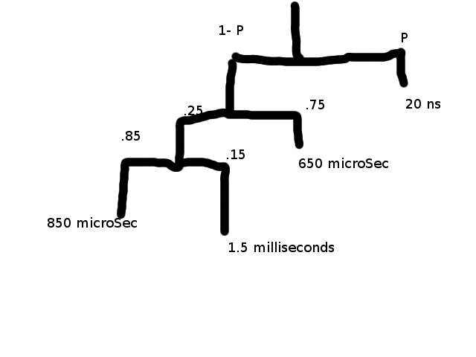
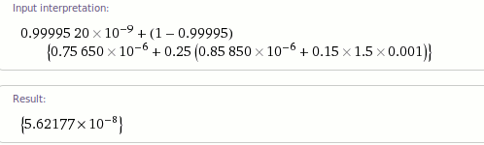

Q2. Consider the following page reference string:
1,2,3,4,2,1,5,6,2,1,2,3,7,6,3,2,1,2,3,6
How many page faults would occur for the following replacement algorithms, assuming three and four frames? The frames are initially empty, so your first unique pages will cost one fault each.
- LRU
3Frames: 14
4Frames: 10
- Optimal
3Frames: 11
4Frames: 8
- FIFO
3Frames: 16
4Frames: 14

Q3. What is the copy-on –write feature, and under what circumferences is it beneficial to use this feature?
Copy-on-Write (COW) allows both parent and child processes to initially share the same pages in memory
If either process modifies a shared page, only then is the page copied
COW allows more efficient process creation as only modified pages are copied
In general, free pages are allocated from a pool of zero-fill-on-demand pages
Why zero-out a page before allocating it?
vfork() variation on fork() system call has parent suspend and child using copy-on-write address space of parent
Designed to have child call exec()
Very efficient

Q4. What is a page fault interrupt?
If a page is referenced and does not exist in memory then a page fault interrupt occurs
Q5. One of the necessary conditions for deadlock is “hold and wait”. What resource allocation policy could an operating system implement to eliminate this condition?
It could use banker's algorithm.
For the Banker's algorithm to work, it needs to know three things:
- How much of each resource each process could possibly request
- How much of each resource each process is currently holding
- How much of each resource the system currently has available
Resources may be allocated to a process only if it satisfies the following conditions:
- request ≤ max, else set error condition as process has crossed maximum claim made by it.
- request ≤ available, else process waits until resources are available.

Source - http://www.thomaskho.com/berkeley-eecs/teaching/cs162fa07/files/handout-week5.pdf
http://en.wikipedia.org/wiki/Banker's_algorithm#Algorithm
Q6. Explain what is meant by the working set of a process?
Δ ≡ working-set window ≡ a fixed number of page references
The working set of a given process is total number of pages referenced in the most recent Δ
- if Δ too small will not encompass entire locality
- if Δ too large will encompass several localities
- if Δ = ∞ ⇒ will encompass entire program
Source – Slides

Q7. Explain the relationship between a “working set” and “thrashing”.
Thrashing occurs If the pages being actively used by the current threads don't all fit in physical memory. Each page fault causes one of the active pages to be moved to disk, so another page fault will occur soon. The system will spend all its time reading and writing pages. Formally if the demand for pages exceeds memory your OS is thrashing and not working. Source - http://www.stanford.edu/~ouster/cgi-bin/cs140-winter12/lecture.php?topic=thrashing

